

AN EXPLAINABLE MACHINE LEARNING FRAMEWORK FOR DIABETES RISK PREDICTION AND PERSONALIZED HEALTH MONITORING

PHASE I REPORT

Submitted by

AADHISESHAN K S (731725405001)

in partial fulfillment for the award of the degree

MASTER OF ENGINEERING IN COMPUTER SCIENCE AND ENGINEERING

M.P. NACHIMUTHU M. JAGANATHAN ENGINEERING COLLEGE,CHENNIMALAI, ERODE – 638 112
ANNA UNIVERSITY::CHENNAI 600 025

NOVEMBER 2026

ANNA UNIVERSITY::CHENNAI 600 025
BONAFIDE CERTIFICATE
Certified that this project report “AN EXPLAINABLE MACHINE LEARNING FRAMEWORK FOR DIABETES RISK PREDICTION AND PERSONALIZED HEALTH MONTORING” is the Bonafide work of AADHISESHAN K S (731725405001) Who carried out the project work under my supervision.

SIGNATURE SIGNATURE

Mr.K.N.SIVAKUMAR M.E., Mrs. D. SUGANTHI M.E.,

HEAD OF THE DEPARTMENT SUPERVISOR

Associate Professor
Department of Computer Science and Engineering,
M.P.Nachimuthu M.Jaganathan Engineering College Chennimalai – 638 112
Assistant Professor
Department of Computer Science and Engineering,
M.P.Nachimuthu M.Jaganathan Engineering College Chennimalai – 638 112

Submitted for the Project Phase -1 Viva Voce Examination held on

INTERNAL EXAMINER EXTERNAL EXAMINER

AN EXPLAINABLE MACHINE LEARNING FRAMEWORK FOR DIABETES RISK PREDICTION AND PERSONALIZED HEALTH MONITORING

ACKNOWLEDGMENT

I wish to express my extreme gratefulness to our beloved correspondent Dr. VASANTHASUDHANANDHEN M.A., B.Ed., for providing all the necessary facilities to undergo our project successfully.
I express my deep sense of our gratitude to our respected principal Dr. M. RAMESH M.E., Ph.D., for providing an excellent technical support through our highly qualified and committed faculty team to carry out this project.
I express my sincere thanks to our Head of the Department Mr. K. N. SIVAKUMAR M.E., Computer Science and Engineering for forwarding us to do the project work by offering adequate duration for complete our project successfully.
I grateful to my guide Mrs. D. SUGNATHI M.E., Assistant Professor, Computer Science and Engineering for his excellent guidance to carry out this project successfully.
I grateful to my project coordinator Mr. S. DINESH KUMAR M.E, Assistant Professor, Computer Science and Engineering for his excellent guidance and continuous instruction to complete our project work.
Finally, I express my heartfelt thanks to faculty members for their constant support and encouragement with excellent guidance, throughout this project work.

சுருக்கம்
நீரிழிவு நோய் (Diabetes Mellitus) என்பது இரத்தத்தில் சர்க்கரையின் அளவு அதிகரிப்பதால் ஏற்படும் ஒரு நாள்பட்ட வளர்சிதை மாற்றக் கோளாறாகும். இது இதய நோய்கள், சிறுநீரக பாதிப்புகள், நரம்பு பாதிப்புகள் மற்றும் பார்வைக் குறைபாடுகள் போன்ற பல்வேறு உடல்நலப் பிரச்சினைகளுக்கு வழிவகுக்கலாம். எனவே, நீரிழிவு நோயின் அபாயத்தை ஆரம்ப நிலையிலேயே கண்டறிவதும், தனிப்பயனாக்கப்பட்ட உடல்நலக் கண்காணிப்பை மேற்கொள்வதும் மிகவும் முக்கியமானதாகும். இந்த ஆய்வு, “நீரிழிவு நோய் அபாயக் கணிப்பு மற்றும் தனிப்பயனாக்கப்பட்ட உடல்நலக் கண்காணிப்பிற்கான விளக்கக்கூடிய இயந்திரக் கற்றல் கட்டமைப்பு” (An Explainable Machine Learning Framework for Diabetes Risk Prediction and Personalized Health Monitoring) என்ற தலைப்பில் முன்மொழியப்படுகிறது.
இந்தத் திட்டம், நோயாளிகளின் உடல்நலத் தரவுகளைப் பயன்படுத்தி நீரிழிவு நோய் அபாயத்தைக் கணிக்க இயந்திரக் கற்றல் (Machine Learning) நுட்பங்களைப் பயன்படுத்துகிறது. இரத்தச் சர்க்கரை அளவு (Glucose), உடல் நிறைக் குறியீடு (BMI), வயது (Age), இரத்த அழுத்தம் (Blood Pressure), இன்சுலின் அளவு (Insulin) மற்றும் தரவுத்தொகுப்பில் கிடைக்கும் பிற தொடர்புடைய மருத்துவக் காரணிகள் ஆகியவை கணிப்பிற்கான உள்ளீடுகளாகப் பயன்படுத்தப்படுகின்றன. Logistic Regression, Decision Tree, Random Forest போன்ற பொருத்தமான இயந்திரக் கற்றல் வழிமுறைகள் பயிற்றுவிக்கப்பட்டு, அவற்றின் செயல்திறன் மதிப்பீட்டு அளவுகோல்களின் அடிப்படையில் ஒப்பிடப்படுகிறது.
மேலும், கணிப்பு முடிவுகளைப் புரிந்துகொள்ள உதவும் வகையில் விளக்கக்கூடிய செயற்கை நுண்ணறிவு (Explainable Artificial Intelligence – XAI) நுட்பங்கள் இக்கட்டமைப்பில் ஒருங்கிணைக்கப்படுகின்றன. SHAP அல்லது LIME போன்ற நுட்பங்கள், ஒரு குறிப்பிட்ட கணிப்பில் எந்தெந்த உடல்நலக் காரணிகள் முக்கியப் பங்கு வகிக்கின்றன என்பதை விளக்க உதவுகின்றன. இதனுடன், பயனர்கள் தங்களுடைய உடல்நலத் தகவல்களை உள்ளீடு செய்து கணிப்பு முடிவுகள், தொடர்புடைய உடல்நலக் காரணிகள் மற்றும் பொதுவான தடுப்பு வழிகாட்டுதல்களைப் பெறுவதற்கான ஊடாடும் பயன்பாடும் உருவாக்கப்படுகிறது.
இயந்திரக் கற்றல், விளக்கக்கூடிய செயற்கை நுண்ணறிவு மற்றும் உடல்நலக் கண்காணிப்பு ஆகியவற்றை ஒருங்கிணைப்பதன் மூலம், நீரிழிவு நோய் அபாயத்தை முன்கூட்டியே மதிப்பிடுவதற்கும் உடல்நல விழிப்புணர்வை மேம்படுத்துவதற்கும் இத்திட்டம் உதவுகிறது. இந்தக் கட்டமைப்பு, மருத்துவ நிபுணர்களின் ஆலோசனை மற்றும் மருத்துவப் பரிசோதனைகளுக்கு மாற்றாக இல்லாமல், ஆரம்பநிலை அபாய மதிப்பீடு மற்றும் உடல்நல மேலாண்மைக்கு ஆதரவளிக்கும் கருவியாகச் செயல்படுகிறது.

ABSTRACT

Diabetes mellitus is a chronic metabolic disorder that affects millions of people worldwide and requires early risk identification and continuous health monitoring to reduce the risk of complications. Traditional methods of diabetes assessment may have limitations in identifying complex relationships between different health attributes. Machine learning provides an effective approach to analyzing health data and predicting diabetes risk.
This project, “An Explainable Machine Learning Framework for Diabetes Risk Prediction and Personalized Health Monitoring,” aims to develop an intelligent system for predicting diabetes risk using machine learning techniques. The system uses relevant health attributes such as glucose level, body mass index (BMI), blood pressure, insulin level, age, and other available patient information. The dataset will be pre-processed through data cleaning, handling missing or invalid values, and feature scaling where necessary. Machine learning algorithms such as Logistic Regression, Decision Tree, and Random Forest will be trained and evaluated using performance metrics including accuracy, precision, recall, F1-score, and the confusion matrix.
To improve model transparency, Explainable Artificial Intelligence (XAI) techniques, particularly SHapley Additive exPlanations (SHAP), will be used to identify the health attributes that contribute to individual predictions. The proposed system aims to present prediction results and understandable explanations through a user-friendly interface, supporting personalized health information and early awareness of potential diabetes risk factors.
The expected outcome is an explainable machine learning framework that combines diabetes risk prediction with personalized health information. The system is intended to support preliminary risk assessment and encourage timely consultation with healthcare professionals. It will serve as a decision-support tool rather than a replacement for medical diagnosis. The effectiveness of the framework will be evaluated using experimental results obtained during implementation.

 | TABLE OF CONTENTS
CHAPTER NO. | TITLE | PAGE NO.
 | ABSTRACT | vii
 | LIST OF FIGURES | x
1 | INTRODUCTION | 1
 | 1.1. OVERVIEW OF THE PROJECT | 3
 | 1.2. PROBLEM DEFINITION | 4
 | 1.3. OBJECTIVE | 5
2 | LITERATURE SURVEY | 6
3 | EXISTING AND PROPOSED SYSTEM | 19
 | 3.1. EXISTING SYSTEM | 19
 | 3.1.1 Disadvantages | 20
 | 3.2. PROPOSED SYSTEM | 21
 | 3.2.1 Advantages | 21
4 | SYSTEM SPECIFICATION | 22
 | 4.1. HARDWARE SPECIFICATION | 22
 | 4.2. SOFTWARE SPECIFICATION | 22

5 | SYSTEM ANALYSIS | 23
 | 5.1. FRONT END | 23
6 | SYSTEM ARCHITECTURE | 27
 | 6.1. SYSTEM ARCHITECTURE DIAGRAM | 27
7 | MODULE DESCRIPTION | 28
 | 7.1. MODULES | 28
 | 7.2. MODULE DESCRIPTION | 28
8 | 8.1. CONCLUSION | 30
 | 8.2. FUTURE ENHANCEMENT | 30
9 | APPENDIX – A – SOURCE CODE | 31
10 | APPENDIX - B – SCREENSHOTS | 35
11 | REFERENCE | 40

LIST OF FIGURES

FIGURE NO | NAME |  | PAGE NO
Fig 6.1 | System Architecture |  | 27
Fig:9.1 | Earthquake Magnitude Distribution |  | 35
Fig.9.2 | Earthquake Depth Distribution |  | 36
Fig.9.3 | Magnitude vs Depth |  | 36
Fig.9.4 |  | Model Accuracy Comparision |  | 39

CHAPTER - 1 INTRODUCTION
Diabetes mellitus is a chronic metabolic disorder characterized by elevated blood glucose levels due to insufficient insulin production or the body's inability to use insulin effectively. It is one of the major public health challenges worldwide and can lead to serious complications, including cardiovascular diseases, kidney damage, nerve disorders, and vision problems. Early identification of diabetes risk is essential for timely medical consultation, preventive care, and effective long-term health management.
Traditional diabetes risk assessment methods primarily depend on clinical examinations, laboratory investigations, medical history, and healthcare professionals' evaluations. Although these methods are important for diagnosing and managing diabetes, identifying individuals at risk at an early stage can be challenging, particularly when several health-related factors interact. With the advancement of Artificial Intelligence (AI) and Machine Learning (ML), data-driven techniques can be used to analyze patient health information and identify patterns associated with diabetes risk.
This project, titled “An Explainable Machine Learning Framework for Diabetes Risk Prediction and Personalized Health Monitoring,” aims to develop a machine learning-based system for predicting diabetes risk using relevant health and demographic features, such as glucose level, body mass index (BMI), age, blood pressure, insulin level, and other available clinical attributes. The framework can employ machine learning algorithms such as Logistic Regression, Decision Tree, Random Forest, and other suitable classification models to identify the model that performs effectively on the selected dataset.
An important feature of the proposed framework is Explainable Artificial Intelligence (XAI), which helps users understand the factors influencing the model's predictions. Instead of providing only a prediction result, the system aims to present interpretable information about the contribution of relevant health features to the predicted risk. The personalized health monitoring component can provide general health insights and preventive recommendations based on available input data and predicted risk levels.

MACHINE LEARNING
Machine Learning is a branch of Artificial Intelligence that enables computer systems learn patterns from historical data and make predictions or decisions without being explicitly programmed for every possible situation. It involves developing algorithms that identify relationships between input features and target outcomes. Machine learning is widely used in healthcare for disease risk prediction, medical image analysis, patient classification, and clinical decision support.
In diabetes risk prediction, machine learning algorithms analyze patient health records to identify patterns associated with diabetes. The input features may include glucose concentration, BMI, age, blood pressure, insulin level, and other relevant medical attributes. Based on these features, a trained classification model estimates the likelihood of diabetes-related outcomes represented in the training dataset.
Model evaluation and explainability are important aspects of healthcare machine learning. Evaluation metrics help assess predictive performance, while explainability techniques help users understand why a model produces a particular result. These capabilities contribute to developing more transparent and interpretable prediction systems.

Types of Machine Learning
1. Supervised Learning
Supervised learning uses labeled datasets in which each training example contains input
features and a corresponding target value. The model learns the relationship between the inputs and the target to predict outcomes for new data.
- Examples: Logistic Regression, Decision Tree, Random Forest, Support Vector Machine.
- Applications: Diabetes risk classification, disease prediction, medical diagnosis support.
- Project relevance: Used to train a model to classify diabetes-related outcomes from available patient health data.
2. Unsupervised Learning
Unsupervised learning identifies hidden patterns, structures, or groups in dataset without predefined target labels.
- Examples: K-Means Clustering, Hierarchical Clustering, Principal Component Analysis (PCA).
- Applications: Patient segmentation, identification of health data patterns, exploratory medical data analysis.
- Project relevance: Can be used to explore similarities among patient records and identify groups with similar health characteristics.
3. Reinforcement Learning
Reinforcement learning enables an agent to learn by interacting with an environment and receiving rewards or penalties based on its actions.
- Examples: Q-Learning, Deep Q-Networks.
- Applications: Adaptive decision-making, robotics, and certain healthcare optimization research applications.
- Project relevance: It is not essential to the initial diabetes prediction model but may be considered in future work involving adaptive health monitoring strategies.

Applications of Machine Learning in the Real World
- Healthcare: Disease risk prediction, patient monitoring, medical image analysis, and clinical decision support.
- Finance: Fraud detection, credit risk assessment, and transaction analysis.
- Retail: Customer segmentation, demand forecasting, and recommendation systems.
- Transportation: Traffic prediction, route optimization, and autonomous driving research.
- Cybersecurity: Intrusion detection, spam classification, and suspicious activity identification.
- Agriculture: Crop disease detection, yield prediction, and soil analysis.

Key Components of the Machine Learning Workflow
- Data Collection: Collecting a suitable diabetes dataset containing relevant health and demographic attributes.
- Data Preprocessing: Handling missing values, duplicate records, inconsistent values, and data quality issues.
- Exploratory Data Analysis: Examining feature distributions, relationships, and patterns in the dataset.
- Feature Selection: Identifying relevant input features for diabetes risk prediction.
- Model Building: Training suitable machine learning classification algorithms.
6. Model Evaluation: Assessing performance using accuracy, precision, recall, F1-score, ROC-AUC, and a confusion matrix, where appropriate.
7. Model Explainability: Applying techniques such as SHAP or LIME to interpret model predictions.
8. Deployment: Integrating the trained model into an interactive application for user input and prediction.
9. Personalized Health Monitoring: Presenting understandable risk information and general preventive health guidance based on available data.

1.1. OVERVIEW OF THE PROJECT
Diabetes is a chronic health condition that requires early identification, regular monitoring, and appropriate medical management. Various health factors, including glucose levels, BMI, age, blood pressure, insulin levels, and family history when available, may contribute to diabetes risk. Analyzing these factors systematically can help identify patterns associated with diabetes and support preventive health awareness.
Traditional diabetes assessment depends on clinical examinations, laboratory tests, and
medical professionals' interpretation of patient information. Although these methods remain essential, data-driven prediction systems can provide additional support by analyzing multiple health features simultaneously. However, a prediction system that only produces a result without explaining its reasoning may be difficult for users to understand and trust.

The proposed project develops an Explainable Machine Learning Framework for Diabetes Risk Prediction and Personalized Health Monitoring. The framework uses a suitable labeled diabetes dataset to train and evaluate machine learning classification algorithms. The dataset may include features such as glucose concentration, BMI, age, blood pressure, insulin level, and other available health indicators. The selected model predicts the diabetes-related outcome represented in the dataset.
To improve transparency, the framework incorporates explainability techniques that identify influential features and help explain individual predictions. Model performance is evaluated using suitable classification metrics, with particular attention to recall and other measures relevant to identifying positive cases. The system can also provide an interactive interface through which users enter health-related parameters and view prediction results, explanations, and general preventive health information.
The personalized health monitoring component aims to present understandable health insights based on the information provided by the user. Depending on the implemented features, the application may support repeated data entry and visualization of changes in recorded health parameters over time. Actual longitudinal monitoring requires repeated measurements and appropriate data storage.
By integrating predictive modelling, explainability, and user-oriented visualization, the proposed framework aims to improve the accessibility and interpretability of diabetes risk assessment. The system is designed as a supportive tool for health awareness and preliminary risk assessment rather than a substitute for laboratory testing, clinical diagnosis, or professional medical advice.

1.2. PROBLEM DEFINITION
Diabetes is a significant healthcare challenge because delayed identification and inadequate monitoring of risk factors may contribute to complications and increased healthcare requirements. Early assessment of diabetes risk is important for encouraging timely medical evaluation and preventive measures.
Conventional diabetes assessment relies on clinical tests, patient history, and healthcare professionals judgment. While these approaches are essential, analyzing multiple patient attributes and identifying complex relationships among them can be challenging when performed without computational assistance. Machine learning provides an opportunity to analyze historical patient data and learn patterns associated with diabetes-related outcomes.
However, several challenges remain in developing an effective diabetes risk prediction system. First, the quality and representativeness of the dataset can influence prediction performance. Second, some classification models may produce predictions that are difficult for users to interpret. Third, reporting only a predicted class or probability does not adequately explain which health features influenced the result. Finally, prediction alone does not provide a convenient mechanism for presenting understandable health insights or supporting repeated monitoring of recorded parameters.
To address these challenges, this project proposes an explainable machine learning framework with the following components:
- Diabetes Risk Prediction: Develop and evaluate suitable supervised machine learning models using relevant health and demographic features.
- Model Performance Evaluation: Compare candidate models using appropriate evaluation metrics to identify a suitable model for the selected dataset.
- Explainable Predictions: Integrate explainability techniques such as SHAP or LIME to identify features influencing individual predictions.
- Personalized Health Monitoring: Present prediction results, relevant health factors, and general preventive guidance through an interactive interface.
- Data Visualization: Provide visual representations of relevant health attributes, model results, and recorded measurements where longitudinal data is available.

1.3. OBJECTIVES
The core objectives of this project are:
- To develop an automated diabetes risk prediction framework using supervised machine learning algorithms and relevant patient health attributes.
- To identify and preprocess important features, such as glucose level, BMI, age, blood pressure, and insulin level, according to the selected dataset.
- To implement and compare suitable classification algorithms, such as Logistic Regression, Decision Tree, Random Forest, and other relevant models, to determine their predictive performance.
- To evaluate the trained models using appropriate performance metrics, including accuracy, precision, recall, F1-score, ROC-AUC, and confusion matrix analysis.
- To integrate Explainable Artificial Intelligence techniques, such as SHAP or LIME, to interpret model behavior and explain the factors influencing individual predictions.
- To develop an interactive user interface that accepts relevant health parameters and presents diabetes risk prediction results in an understandable format.
- To provide general preventive health information and personalized insights based on the available input data, without presenting automated predictions as medical diagnoses.
- To incorporate data visualization features that help users understand relevant health attributes, influential risk factors, and recorded health trends when repeated measurements are available.
- To design a modular and extensible framework that can be further improved through additional clinical validation, suitable datasets, and future health-monitoring capabilities.

CHAPTER-2
  - LITERATURE SURVEY
    - MULTIDISCIPLINARY TEAM PROCESSES PARALLEL NATURAL DISASTER PREPAREDNESS AND RESPONSE: A QUALITATIVE CASE STUDY
ShaonLahiri et.al has proposed in this paper Cross-disciplinary (multidisciplinary, interdisciplinary, or transdisciplinary) teams are increasingly recognized as crucial alliances required for solving complex problems, particularly those attributable to natural disasters. Despite this recognition, there has been limited research examining the factors necessary for successful crossdisciplinary collaboration at the outset of a research initiative to address natural disaster preparedness and response. The purpose of this study was to explore the facilitators of and barriers to such collaboration through a case study of a multidisciplinary research initiative at an urban East Coast university in the United States. Using an applied qualitative approach, we conducted individual semi-structured interviews with initiative members to explore facilitators and barriers to natural disaster preparedness and response, and initiative members‘ attitudes, perceptions, and expectations regarding multidisciplinary collaboration. We identified several common themes across natural disaster preparedness and response efforts and multidisciplinary research collaborations, such as greater human and financial resources. Additionally, we identified several themes unique to perceptions of multidisciplinary research collaboration, such as the importance of clearly defined structures, and the needs of all parties being met. Findings may serve as a framework for multidisciplinary academic collaborations preparing for and responding to natural disasters, as well as multidisciplinary collaboration in general. The outlook for future natural disasters is worrying, given the already observable and accelerating effects of climate change. Between 1998 and 2017, over 1.3 million people died, and 4.4 billion people were injured, homeless, displaced, or in need of emergency assistance due to earthquakes, tsunamis, floods, and other extreme weather events globally [1]. Rising temperatures alter the Earth‘s hydrologic cycle, resulting in intensified periods of drought and flooding, and increases in humidity result in a higher frequency of tropical storms [2]. This preliminary analysis focused on

the early stages of a multidisciplinary initiative and highlighted numerous benefits resulting from multidisciplinary teams. The study also indicated facilitators of and barriers to the achievement of multidisciplinary initiative outcomes. The themes we uncovered emerged from participants from multiple disciplines with various experiences, suggesting that findings may apply to other multidisciplinary research initiatives. Future research should include the investigation of collaboration over time and how the dynamicity and needs of the team may differ depending on its stage of development. As is the case with any team, success will depend in part on the time that members devote to developing relationships, forging trust and shared meanings, and defining a collective identity.

THE ROLE OF ARTIFICIAL NEURAL NETWORK AND MACHINE LEARNING IN UTILIZING SPATIAL INFORMATION
Akash Goel et.al has proposed in this paper In this age of the fourth industrial revolution 4.0, the digital world has a plethora of data, including the internet of things, mobile, cybersecurity, social media, forecasts, health data, and so on. The expertise of machine learning and artificial intelligence (AI) is required to soundly evaluate the data and develop related smart and automated applications, These fields use a variety of machine learning techniques including supervised, unsupervised, and reinforcement learning. The objective of the study is to present the role of artificial neural networks and machine learning in utilizing spatial information. Machine learning and AI play an increasingly important role in disaster risk reduction from hazard mapping and forecasting severe occurrences to real-time event detection, situational awareness, and decision assistance. Some of the applications employed in the study to analyze the various ANN domains included weather forecasting, medical diagnosis, aerospace, facial recognition, stock market, social media, signature verification, forensics, robotics, electronics hardware, defense, and seismic data gathering. Machine learning determines the many prediction models for problems involving classification, regression, and clustering using known variables and locations from the training dataset, spatial data that is based on tabular data creates different observations that are geographically related to one another for unknown factors and places. The study presents that the Recurrent neural network and convolutional neural network are the best method in

spatial information processing, healthcare, and weather forecasting with greater than 90% accuracy. Machine learning is a branch of artificial intelligence that use a variety of probabilistic, statistical, and optimization techniques to permit computers to —learn‖ from past examples and detect hard-to-observe patterns in vast, noisy, or complex data sets. Medical applications, especially those that rely on complex proteomic and genomic measurements, are a good example of this, which will benefit greatly from this capability. Artificial intelligence (AI) refers to the creation of computer-based systems that can perform activities that are comparable to human intelligence. Artificial intelligence, in reality, encompasses the entire learning scale and is not restricted to machine learning. Learning representation, natural language processing, and deep learning are examples of AI (NLP). Computational programs that replicate and simulate human intelligence in learning and problem-solving are referred to as AI. Artificial intelligence in medicine employs computer algorithms to extract information from raw data to make accurate and right medical decisions.

ATTENTION-CONVNET NETWORK FOR OCEAN-FRONT PREDICTION VIA REMOTE SENSING SST IMAGES
Yuting Yang et.al has proposed in this paper Ocean front is one typical geophysical phenomenon acting as oases in the ocean for fishes and marine mammals. Accurate ocean-front prediction is critical for fishery and navigation safety. However, the formation and evolution of ocean fronts are inherently nonlinear and are influenced by various factors such as ocean currents, wind fields, and temperature changes, making ocean-front prediction a considerable challenge. This study proposes a temporal-sensitive network named Attention-ConvNet to address this challenge. Ocean fronts exhibit significant multiscale characteristics, requiring analysis and prediction across various temporal and spatial scales. The proposed network designs a hierarchical attention mechanism (HAM) that efficiently prioritizes relevant spatial and temporal information to meet the specific requirement. What is more, the proposed network uses a complex hierarchical branching convolutional network (HBCNet) architecture, which allows our network to leverage the complementary strengths of spatial and temporal information, effectively capturing the dynamic and complex variations in ocean fronts. In general, the network prioritizes and focuses on the most relevant information of front

dynamics, which ensures its ability to effectively predict the ocean front. External experiments demonstrate that our network significantly outperforms conventional methods, confirming its capability for precise ocean-front prediction. This study presents a comprehensive approach for ocean-front prediction by proposing and integrating the HAM, Spatial ConvNet, and HBCNet into our network. Specifically, our network uses concatenated Spatial ConvNet and HBCNet to enhance its ability to capture spatiotemporal features. A notable aspect of our prediction network is its attention mechanism, particularly a relation-aware mechanism that incorporates pairwise relationships between ConvNet predictions and predicted ocean-front time-series. This mechanism enhances prediction performance through the identification of pertinent information, weighted summation, and result reweighting. Moreover, we refine mathematical functions and network architectures through controlled experimental comparisons, selecting optimal loss function and activation functions for integration into our network. In addition, comparative experiments demonstrate the effectiveness of the spatial–temporal ConvNet, multilayer convolutional structure, multibranch convolutional architecture, and HAM in improving the accuracy of ocean-front prediction.

EXPLAINABLE SPATIALLY-EXPLICIT GEOAI IN URBAN ANALYTICS
Pengyuan Liu et.al has proposed in this paper Geospatial artificial intelligence (GeoAI) is proliferating in urban analytics, where graph neural networks (GNNs) have become one of the most popular methods in recent years. However, along with the success of GNNs, the black box nature of AI models has led to various concerns (e.g., algorithmic bias and model misuse) regarding their adoption in urban analytics, particularly when studying socio-economics where high transparency is a crucial component of social justice. Therefore, the desire for increased model explainability and interpretability has attracted increasing research interest. This article proposes an explainable spatially-explicit GeoAI-based analytical method that combines a graph convolutional network (GCN) and a graph-based explainable AI (XAI) method, called GNNExplainer. Here we showcase the ability of our proposed method in two studies within urban analytics: traffic volume prediction and population estimation in the tasks

of a node classification and a graph classification, respectively. For these tasks, we used Street View Imagery (SVI), a trending data source in urban analytics. We extracted semantic information from the images and assigned them as features of urban roads. The GCN first provided reasonable predictions related to these tasks by encoding roads as nodes and their connectivities and networks as graphs. The GNNExplainer then offered insights into how certain predictions are made. Through such a process, practical insights and conclusions can be derived from the urban phenomena studied here. In this paper we also set out a path for developing XAI in future urban studies. The increasing awareness of open data initiatives for building smarter cities (Neves et al., 2020) has brought about a —digital turn‖ into urban studies (Ash et al., 2018). Thanks to the abundant data now available, modern urban analytics seeks advanced technologies, and dedicated models and algorithms, to support better city governance with detailed analysis to aid urban planning processes that tackle socio-economic and environmental problems (Lei et al., 2023b; Wang and Biljecki, 2022; Liu and Biljecki, 2022; Song et al., 2022; YossefRavid and Aharon-Gutman, 2022; Kang et al., 2019; Carra and Barthelemy, 2019; Yeh, 1988). Embracing the current —digital turn‖ in urban geography, GeoAI-based models are increasingly being used to support a better understanding of the urban environment and aid planning processes. Most studies use the predictive ability of GeoAI models, but the desire to understand the model opens up a research agenda to develop explainable AI (XAI) models (Liu and Biljecki, 2022). Here we proposed an explainable spatially-explicit GeoAI method that offers both predictive power and the explanability of the results to gain further insights into the urban environment. Our method used a GCN to explicitly encode location information as a graph structure, contributing to its powerful predictive ability. Then in combination with the XAI model GNNExplainer to interpret the model‘s predictions, we provided a road network and region-level understanding of the environment.

2.1.5 GEOSPATIAL DATA MANAGEMENT RESEARCH: PROGRESS AND FUTURE DIRECTIONS
Martin Breunig et.al has proposed in this paper Without geospatial data management, today‘s challenges in big data applications such as earth observation, geographic information system/building information modeling (GIS/BIM) integration,

and 3D/4D city planning cannot be solved. Furthermore, geospatial data management plays a connecting role between data acquisition, data modelling, data visualization, and data analysis. It enables the continuous availability of geospatial data and the replicability of geospatial data analysis. In the first part of this article, five milestones of geospatial data management research are presented that were achieved during the last decade. The first one reflects advancements in BIM/GIS integration at data, process, and application levels. The second milestone presents theoretical progress by introducing topology as a key concept of geospatial data management. In the third milestone, 3D/4D geospatial data management is described as a key concept for city modelling, including subsurface models. Progress in modelling and visualization of massive geospatial features on web platforms is the fourth milestone which includes discrete global grid systems as an alternative geospatial reference framework. The intensive use of geosensor data sources is the fifth milestone which opens the way to parallel data storage platforms supporting data analysis on geosensors. In the second part of this article, five future directions of geospatial data management research are presented that have the potential to become key research fields of geospatial data management in the next decade. Geo-data science will have the task to extract knowledge from unstructured and structured geospatial data and to bridge the gap between modern information technology concepts and the geo-related sciences. Topology is presented as a powerful and general concept to analyze GIS and BIM data structures and spatial relations that will be of great importance in emerging applications such as smart cities and digital twins. Data-streaming libraries and —in-situ‖ geo-computing on objects executed directly on the sensors will revolutionize geo-information science and bridge geo-computing with geospatial data management. Advanced geospatial data visualization on web platforms will enable the representation of dynamically changing geospatial features or moving objects‘ trajectories. Finally, geospatial data management will support big geospatial data analysis, and graph databases are expected to experience a revival on top of parallel and distributed data stores supporting big geospatial data analysis.

SPECTRALGPT: SPECTRAL REMOTE SENSING FOUNDATION MODEL
DanfengHong et.al has proposed in this paper The foundation model has recently garnered significant attention due to its potential to revolutionize the field of visual representation learning in a self-supervised manner. While most foundation models are tailored to effectively process RGB images for various visual tasks, there is a noticeable gap in research focused on spectral data, which offers valuable information for scene understanding, especially in remote sensing (RS) applications. To fill this gap, we created for the first time a universal RS foundation model, named SpectralGPT, which is purpose-built to handle spectral RS images using a novel 3D generative pretrained transformer (GPT). Compared to existing foundation models, SpectralGPT
1) accommodates input images with varying sizes, resolutions, time series, and regions in a progressive training fashion, enabling full utilization of extensive RS big data; 2) leverages 3D token generation for spatial-spectral coupling; 3) captures spectrally sequential patterns via multi-target reconstruction; 4) trains on one million spectral RS images, yielding models with over 600 million parameters. Our evaluation highlights significant performance improvements with pretrainedSpectralGPT models, signifying substantial potential in advancing spectral RS big data applications within the field of geoscience across four downstream tasks: single/multi-label scene classification, semantic segmentation, and change detection. The explosive development of foundation models represents a significant technological revolution following the advent of deep learning. Currently, various industries are witnessing significant leaps in technology and application advancements, largely driven by the emergence of foundation models. The RS field is no exception, with numerous EO applications, reaping significant benefits. Spectral imaging has gained recognition in EO for its ability to provide rich insights into the composition of observed objects and materials, making it a transformative technology with vast potential to address global challenges and reshape various industries. However, the everexpanding availability of spectral data from various RS platforms undeniably presents formidable challenges. There is a pressing demand for the development of foundation models specifically designed for spectral RS data. To fully unlock and leverage the potential of spectral RS data, it is imperative to overcome and resolve several challenging obstacles. These include efficiently

processing and utilizing diverse RS spectral big data from various sources, extracting meaningful knowledge representations from complex spatial-spectral mixed information, and tackling the spectral degradation of neighboring spectral relevance modeling.

SPECTRALGPT: SPECTRAL REMOTE SENSING FOUNDATION MODEL
Danfeng Hong et.al has proposed in this paper The foundation model has recently garnered significant attention due to its potential to revolutionize the field of visual representation learning in a self-supervised manner. While most foundation models are tailored to effectively process RGB images for various visual tasks, there is a noticeable gap in research focused on spectral data, which offers valuable information for scene understanding, especially in remote sensing (RS) applications. To fill this gap, we created for the first time a universal RS foundation model, named SpectralGPT, which is purpose-built to handle spectral RS images using a novel 3D generative pretrained transformer (GPT). Compared to existing foundation models, SpectralGPT
1) accommodates input images with varying sizes, resolutions, time series, and regions in a progressive training fashion, enabling full utilization of extensive RS big data; 2) leverages 3D token generation for spatial-spectral coupling; 3) captures spectrally sequential patterns via multi-target reconstruction; 4) trains on one million spectral RS images, yielding models with over 600 million parameters. Our evaluation highlights significant performance improvements with pretrainedSpectralGPT models, signifying substantial potential in advancing spectral RS big data applications within the field of geoscience across four downstream tasks: single/multi-label scene classification, semantic segmentation, and change detection. The explosive development of foundation models represents a significant technological revolution following the advent of deep learning. Currently, various industries are witnessing significant leaps in technology and application advancements, largely driven by the emergence of foundation models. The RS field is no exception, with numerous EO applications, reaping significant benefits. Spectral imaging has gained recognition in EO for its ability to provide rich insights into the composition of observed objects and materials, making it a transformative technology with vast potential to address global challenges and reshape

various industries. However, the everexpanding availability of spectral data from various RS platforms undeniably presents formidable challenges. There is a pressing demand for the development of foundation models specifically designed for spectral RS data. To fully unlock and leverage the potential of spectral RS data, it is imperative to overcome and resolve several challenging obstacles. These include efficiently processing and utilizing diverse RS spectral big data from various sources, extracting meaningful knowledge representations from complex spatial-spectral mixed information, and tackling the spectral degradation of neighboring spectral relevance modeling.

MACHINE LEARNING IN DISASTER MANAGEMENT: RECENT DEVELOPMENTS IN METHODS AND APPLICATIONS
VasileiosLinardos et.al has proposed in this paper Recent years include the world‘s hottest year, while they have been marked mainly, besides the COVID-19 pandemic, by climate-related disasters, based on data collected by the Emergency Events Database (EM-DAT). Besides the human losses, disasters cause significant and often catastrophic socioeconomic impacts, including economic losses. Recent developments in artificial intelligence (AI) and especially in machine learning (ML) and deep learning (DL) have been used to better cope with the severe and often catastrophic impacts of disasters. This paper aims to provide an overview of the research studies, presented since 2017, focusing on ML and DL developed methods for disaster management. In particular, focus has been given on studies in the areas of disaster and hazard prediction, risk and vulnerability assessment, disaster detection, early warning systems, disaster monitoring, damage assessment and post-disaster response as well as cases studies. Furthermore, some recently developed ML and DL applications for disaster management have been analyzed. A discussion of the findings is provided as well as directions for further research. Natural and man-made disasters impact the lives of millions of people worldwide each year [1]. Often it is the case that human lives are lost as a result of these events. Besides human losses, significant impacts on infrastructure and properties are caused by disasters. Disaster management operations are performed before, during and after the occurrence of a disaster, aiming at preventing human losses, protecting people and infrastructure, reducing the impacts on

economy and reestablishing a state of normalcy [2]. The complexity of the disasters and the criticality and complexity of disaster operations require robust decision making, enhanced by information technology and in particular AI [2]. Effective and informed disaster management is necessary to address the scale and the impact of disasters and in recent years has been leveraged by advances in ML and DL [3]. Natural disasters are one of the major causes of human lives loss and damage to infrastructure and property. Advances in ML and DL have been increasingly used to manage with the complexity of disasters. In this paper, a review study has been carried out to investigate how ML and DL techniques have been used in various areas of disaster management to assist disaster management operations and improve their performance. For this purpose, those papers which have been published since 2017 have been targeted, dividing them in categories which include the different phases and subphases of a disaster event. In these categories, various ML and DL techniques have been used for different types of disasters including floods, lava flow, earthquakes, typhoons, hurricanes, landslides among others. Reviewed studies focused on the areas of disaster and hazard prediction, risk and vulnerability assessment, disaster detection, early warning systems, disaster monitoring, damage assessment and post-disaster response as well as cases studies and applications. Challenges and future research directions have been discussed. Future research should be directed towards leveraging ML and DL for improving the performance of disaster recovery operations. Disaster recovery operations should be sustainable; therefore, research should focus on using ML and DL to enhance mitigation efforts, reduce vulnerabilities, and assess resilience including of key infrastructure.

TOWARD AN INTEGRATED DISASTER MANAGEMENT APPROACH: HOW ARTIFICIAL INTELLIGENCE CAN BOOST DISASTER MANAGEMENT
Sheikh Kamran Abid et.al has proposed in this paper Technical and methodological enhancement of hazards and disaster research is identified as a critical question in disaster management. Artificial intelligence (AI) applications, such as tracking and mapping, geospatial analysis, remote sensing techniques, robotics, drone technology, machine learning, telecom and network services, accident and hot spot

analysis, smart city urban planning, transportation planning, and environmental impact analysis, are the technological components of societal change, having significant implications for research on the societal response to hazards and disasters. Social science researchers have used various technologies and methods to examine hazards and disasters through disciplinary, multidisciplinary, and interdisciplinary lenses. They have employed both quantitative and qualitative data collection and data analysis strategies. This study provides an overview of the current applications of AI in disaster management during its four phases and how AI is vital to all disaster management phases, leading to a faster, more concise, equipped response. Integrating a geographic information system (GIS) and remote sensing (RS) into disaster management enables higher planning, analysis, situational awareness, and recovery operations. GIS and RS are commonly recognized as key support tools for disaster management. Visualization capabilities, satellite images, and artificial intelligence analysis can assist governments in making quick decisions after natural disasters. A disaster is a phenomenon that may inflict harm on a community through loss of human life, damage to the environment, or economic loss. It is beyond the community‘s capacity to react [1]. According to the Center for Research on the Epidemiology of Disasters, disaster-affected countries lost
$2.9 trillion in economic value between 1998 and 2017 [2]. With approximately $1 trillion in losses, the United States leads the pack, followed by China, Japan, and India. According to the UN Refugee Agency, the rate of calamities has nearly doubled throughout the last 20 years. Since 1995, the Asia–Pacific region has been the most vulnerable [3]. As highlighted in Figure 1, global disaster losses are a share of GDP from 1990 to 2017. This research focused on the role of artificial intelligence in disaster management, and how these applications can boost disaster management. In particular, this study reviewed the different applications of AI to identify the methods and approaches implemented in disaster management phases. This review supports that AI models are valuable in boosting disaster management. We also concluded that the current trends focus on how to respond and mitigate a disaster. Geospatial technology continues to expand and provide a timely solution and provides a rich agenda for GI Science. Therefore, it is imperative to develop and think about the geographical implication. Nowadays, GIS and RS are powerful tools, providing a new capability to understand emergencies.

DEVELOPMENT OF A NOVEL HYBRID MULTI-BOOSTING NEURAL NETWORK MODEL FOR SPATIAL PREDICTION OF URBAN FLOOD
Hamid Darabi et.al has proposed in this paper Urbanization increases impervious surfaces, thereby reducing infiltration and groundwater recharge, and increasing surface water runoff and flood risk (Chen et al. 2009; Kalantari et al. 2017). Flooding, as a result of high-intensity precipitation, quick snowmelt and increased river levels (Fernandez and Lutz 2010; Darabi et al. 2019) can damage private and public properties, transportation systems and businesses. It can also cause loss of life, erosion and environmental pollution, and generate other social, environmental and economic problems (UNISDR (United Nation Office for Disaster Risk Reduction) 2009). Urban planning and policy can reduce the adverse impacts of floods (Brody et al. 2007, 2017). High-accuracy flood susceptibility maps that identify areas susceptible to flooding can help in this effort to mitigate losses (Buchele et al. € 2006; Ahmadisharaf and Kalyanapu 2019; Darabi et al. 2019; Rahmati et al. 2020). Modelling flood inundation and spatially distributed hydrological processes using hydraulic and hydrological-based models can be challenging in urban areas, which are often data-scarce and ungauged, particularly highly heterogeneous urbanized areas (Salvadore et al. 2015; Darabi et al.
2016). In the past two decades, researchers have sought to generate flood susceptibility maps for ungauged regions and data-scarce areas using multi-criteria decision analysis (or knowledge-based) approaches. These include the analytic hierarchy process (AHP) (Fernandez and Lutz 2010; Ouma and Tateishi 2014; Bathrellos et al. 2016; Gigovic et al. 2017; Moghadas et al. 2019; Souissi et al. 2020), the analytical network process (Azareh et al. 2019; Kanani-Sadat et al. 2019) and a technique for order of preference by similarity to ideal solution (Kim et al. 2019). Interestingly, Rahmati et al. (2016) compared flood susceptibility maps produced with the hydrologic engineering centre-river analysis system (HEC-RAS), a popular hydraulic-based model, and with the AHP model, and concluded that AHP is a more effective tool for flood susceptibility mapping (i.e. flood extent), especially in data-scarce regions, but that it cannot provide reliable predictions of flood depth. Activities such as urbanization enhance the likelihood of urban floods. This study combined the multi-boosting technique with the MLPNN model to produce a novel hybridized model (MultiB-MLPNN) for urban flood susceptibility mapping. Its performance was assessed by comparing the flood

susceptibility maps produced by standalone MLPNN and two models commonly used for flood susceptibility mapping, RF and BRT.

CHAPTER – 3
EXISTING AND PROPOSED SYSTEM
  - EXISTING SYSTEM

The existing systems for diabetes risk prediction primarily rely on traditional statistical methods, medical examinations, and conventional machine learning techniques. These systems analyze health-related parameters such as glucose level, blood pressure, body mass index (BMI), insulin level, age, and other relevant clinical attributes to identify the possibility of diabetes. Some existing approaches use algorithms such as Logistic Regression, Decision Tree, Support Vector Machine (SVM), and Random Forest to classify individuals based on their diabetes risk.
Although these methods provide useful predictions, many systems focus mainly on classification accuracy and do not sufficiently explain the reasons behind their predictions. Some models are trained using limited datasets, which may affect their ability to generalize to different populations. Additionally, missing values, imbalanced data, and irrelevant features can influence model performance. Most conventional systems also provide limited personalized health insights and do not adequately support continuous health monitoring.
To overcome these limitations, there is a need for an explainable machine learning framework that combines diabetes risk prediction, model interpretation, and personalized health monitoring. The proposed system aims to improve transparency and usability by providing understandable prediction explanations and relevant health insights through an interactive application.

DRAWBACKS OF EXISTING SYSTEM:

- Traditional statistical methods may not adequately capture complex, non-linear relationships among different health parameters.
- Many existing systems provide only diabetes classification results without explaining the factors influencing the prediction.
- Incomplete datasets, missing values, noisy data, and class imbalance can reduce prediction reliability.
- Models trained on limited or unrepresentative datasets may not perform consistently across different populations.
- Most conventional systems provide limited personalized health insights based on individual health parameters.
- Some systems lack an interactive interface for users to enter health information, view prediction results, and understand model performance.
- Limited integration of explainable AI techniques reduces the transparency and interpretability of predictions.
- Many systems do not support historical health tracking or continuous monitoring of changes in health parameters.

PROPOSED SYSTEM

The proposed system introduces an Explainable Machine Learning Framework for Diabetes Risk Prediction and Personalized Health Monitoring. It uses machine learning algorithms such as Logistic Regression, Decision Tree, and Random Forest to predict diabetes risk based on relevant health parameters, including glucose level, BMI, blood pressure, insulin level, age, and other available dataset attributes.
The system performs data preprocessing operations such as handling missing values, removing duplicate records where appropriate, encoding categorical variables, and scaling numerical features when required. The processed dataset is used to train and evaluate the machine learning models. Performance metrics such as accuracy, precision, recall, F1-score, and confusion matrix are used to compare the models and identify a suitable model for prediction.
To improve transparency, the framework incorporates Explainable AI techniques such as SHAP (SHapley Additive exPlanations) and LIME (Local Interpretable Model-agnostic Explanations). These techniques help explain how individual health parameters contribute to a prediction. The application also provides personalized health insights based on the user's input values and prediction results, along with visualizations that support better understanding of health-related information.
The system can be implemented as an interactive web application using Streamlit, allowing users to enter health parameters, obtain a diabetes risk prediction, view explanations, and access relevant health-monitoring suggestions. The proposed framework is intended to support preliminary risk awareness and preventive healthcare. It does not replace professional medical diagnosis or treatment.

3.1.2. ADVANTAGES OF PROPOSED SYSTEM:

- The use of multiple machine learning algorithms enables systematic model comparison and the selection of a suitable prediction model.
- Automated data preprocessing improves data quality and supports more reliable model training and evaluation.
- Explainable AI techniques such as SHAP and LIME help users understand the factors influencing individual predictions.
- Personalized health insights provide users with relevant information based on their health parameters and prediction results.
- Interactive visualizations make prediction results and important health factors easier to understand.
- A user-friendly web application simplifies data entry and access to prediction results without requiring programming knowledge.
- The modular framework can be extended with additional machine learning models, new datasets, and further explainability techniques.
- Future integration with wearable devices and historical health records can support more comprehensive health monitoring.
- The system encourages early risk awareness and preventive healthcare practices while emphasizing the importance of professional medical consultation.

CHAPTER – 4

SYSTEM SPECIFICATION

  - SOFTWARE REQUIREMENTS

    - Operating System: Windows 10
    - Programming Language: Python

HARDWARE REQUIREMENT

    - Processor : I3
    - Ram : 4 GB
    - Hard disk : 500 GB
    - Monitor : 15’’ color
    - Speed : 2.80GHz
    - Mouse : Logitech
    - Keyboard : 110 keys enhanced

CHAPTER – 5 SYSTEM ANALYSIS
  - FRONT END

PYTHON

Introduction

Python is a general-purpose interpreted, interactive, object-oriented, and high-level programming language. It was created by Guido van Rossum during 1985- 1990. Like Perl, Python source code is also available under the GNU General Public License (GPL). This tutorial gives enough understanding on Python programming language.

Python is a high-level, interpreted, interactive and object-oriented scripting language. Python is designed to be highly readable. It uses English keywords frequently where as other languages use punctuation, and it has fewer syntactical constructions than other languages.

    - Python is Interpreted − Python is processed at runtime by the interpreter. You do not need to compile your program before executing it. This is similar to PERL and PHP.
    - Python is Interactive − You can actually sit at a Python prompt and interact with the interpreter directly to write your programs.
    - Python is Object-Oriented − Python supports Object-Oriented style or technique of programming that encapsulates code within objects.
    - Python is a Beginner's Language − Python is a great language for the beginner-level programmers and supports the development of a wide range of applications from simple text processing to www browsers to games.

History of Python

- Python was developed by Guido van Rossum in the late eighties and early nineties at the National Research Institute for Mathematics and Computer Science in the Netherlands.
- Python is derived from many other languages, including ABC, Modula-3, C, C++, Algol-68, SmallTalk, and Unix shell and other scripting languages.
- Python is copyrighted. Like Perl, Python source code is now available under the GNU General Public License (GPL).
- Python is now maintained by a core development team at the institute, although Guido van Rossum still holds a vital role in directing its progress.
Python Features
Python's features include −
      - Easy-to-learn − Python has few keywords, simple structure, and a clearly defined syntax. This allows the student to pick up the language quickly.
      - Easy-to-read − Python code is more clearly defined and visible to the eyes.
      - Easy-to-maintain − Python's source code is fairly easy-to-maintain.
      - A broad standard library − Python's bulk of the library is very portable and cross-platform compatible on UNIX, Windows, and Macintosh.
      - Interactive Mode − Python has support for an interactive mode which allows interactive testing and debugging of snippets of code.
      - Portable − Python can run on a wide variety of hardware platforms and has the same interface on all platforms.
      - Extendable − You can add low-level modules to the Python interpreter. These modules enable programmers to add to or customize their tools to be more efficient.
      - Databases − Python provides interfaces to all major commercial databases.

      - GUI Programming − Python supports GUI applications that can be created and ported to many system calls, libraries and windows systems, such as Windows MFC, Macintosh, and the X Window system of Unix.
      - Scalable − Python provides a better structure and support for large programs than shell scripting.
      - Apart from the above-mentioned features, Python has a big list of good features, few are listed below −
      - It supports functional and structured programming methods as well as OOP.
      - It can be used as a scripting language or can be compiled to byte-code for building large applications.
      - It provides very high-level dynamic data types and supports dynamic type checking.
      - It supports automatic garbage collection.
      - It can be easily integrated with C, C++, COM, ActiveX, CORBA, and Java.

Local Environment Setup

Open a terminal window and type "python" to find out if it is already installed and which version is installed.
    - Unix (Solaris, Linux, FreeBSD, AIX, HP/UX, SunOS, IRIX, etc.)
    - Win 9x/NT/2000
    - Macintosh (Intel, PPC, 68K)
    - OS/2
    - DOS (multiple versions)
    - PalmOS
    - Nokia mobile phones
    - Windows CE
    - Acorn/RISC OS
    - BeOS
    - Amiga
    - VMS/OpenVMS
    - QNX
    - VxWorks
    - Psion
    - Python has also been ported to the Java and .NET virtual machines.

Integrated Development Environment
You can run Python from a Graphical User Interface (GUI) environment as well, if you have a GUI application on your system that supports Python.
    - Unix − IDLE is the very first Unix IDE for Python.
    - Windows − PythonWin is the first Windows interface for Python and is an IDE with a GUI.
    - Macintosh − The Macintosh version of Python along with the IDLE IDE is available from the main website, downloadable as either MacBinary or BinHex'd files.
If you are not able to set up the environment properly, then you can take help from your system admin. Make sure the Python environment is properly set up and working perfectly fine.

CHAPTER – 6

  - SYSTEM ARCHITECTURE DIAGRAM

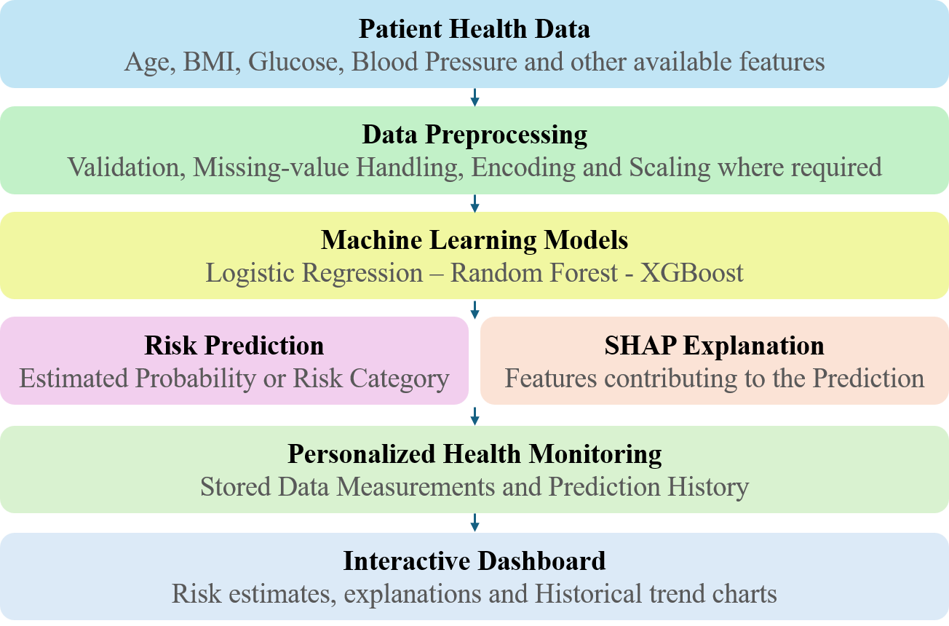

Figure 6.1 System Architecture

CHAPTER-7

MODULES DESCRIPTION

  - MODULES

    - Dataset Preparation
    - Data Preprocessing& EDA
    - Model Architecture
    - Model Training
    - Model Evaluation and Visualization

  - METHODOLOGY (Modules):

(Phase 1) EARTHQUAKE

- Dataset Preparation

A custom earthquake dataset is prepared from seismic records, containing features such as Latitude, Longitude, Depth, Magnitude, and Date-Time. The target variable is labeled into Low, Medium, and High risk levels based on earthquake magnitude thresholds.

Data Preprocessing& EDA

The raw dataset was cleaned by removing duplicate records and handling missing values. Feature engineering was applied to extract temporal information (year, month, day, hour, weekday) from the Date-Time field. Magnitudes were categorized into three risk classes (low, medium, high). Continuous features were normalized, and categorical features were converted to numerical form using label encoding.

Model Architecture

The system uses a Random Forest Classifier, an ensemble method combining multiple decision trees. The model is trained on spatial and temporal features (latitude,

longitude, depth, year, month, etc.) to predict the encoded risk levels. The Random Forest model was configured with 100 trees to learn patterns and classify risk.

Model Training

The dataset was split into training and testing subsets (80:20 ratio). The Random Forest algorithm was trained by building multiple decision trees, combining their outputs to improve accuracy and reduce overfitting. This process enabled the model to capture the relationship between seismic characteristics and risk levels.

Model Evaluation and Visualization

The trained model was evaluated on the unseen test data. Performance was assessed using a classification report and confusion matrix, which provide insights into accuracy, precision, recall, and F1-score for each risk category.
(Phase 2) FLOOD

  - Dataset Preparation

  - Data Preprocessing & EDA

  - Model Architecture

  - Model Training

  - Model Evaluation and Visualization

CHAPTER – 8 CONCLUSION

8.1. CONCLUSION

In this project of the research, the earthquake risk prediction system was successfully developed and implemented using machine learning techniques. By utilizing features such as latitude, longitude, depth, and magnitude, the Logistic Regression and Random Forest models were trained and evaluated to classify earthquake risk levels into Low, Medium, and High categories. The Random Forest model achieved superior performance with an impressive accuracy of 99.96%, outperforming Logistic Regression‘s 97.64%, demonstrating its strong ability to handle complex and nonlinear relationships in seismic data. This system effectively contributes to early warning and disaster preparedness by providing accurate risk assessments based on historical earthquake data.

8.2.FUTURE ENHANCEMENT

In the next phase, the project will focus on developing a Flood Risk Level Prediction System using the provided dataset, which includes 21 crucial environmental and socio-economic parameters such as Monsoon Intensity, Topography Drainage, River Management, Urbanization, Deforestation, Climate Change, and Drainage Systems. These features play a vital role in influencing flood occurrence and severity. The model will employ advanced machine learning and deep learning algorithms to classify flood probability into Low, Medium, and High risk levels. By analyzing complex interdependencies among climatic, geographical, and human-related factors, the proposed system aims to deliver a highly accurate and adaptive flood risk prediction model. This enhancement will contribute significantly to proactive disaster management, allowing authorities to implement effective flood prevention, mitigation, and response strategies based on real-time risk assessments.

CHAPTER-9

import pandas as pd # Load dataset
df = pd.read_csv("database.csv")

APPENDIX -A SOURCE CODE

# Replace with your downloaded CSV path print(df.head()) print(df.info())
# Keep only required columns
df_model = df[['Date','Time','Latitude','Longitude','Depth','Magnitude']].dropna() # Convert Date and Time to datetime
df_model['Datetime'] = pd.to_datetime(df_model['Date'] + ' ' + df_model['Time'], errors='coerce')
# Extract featuresdf_model['Year'] = df_model['Datetime'].dt.year
df_model['Month'] = df_model['Datetime'].dt.month df_model['Day'] = df_model['Datetime'].dt.day df_model['Hour'] = df_model['Datetime'].dt.hour df_model['Weekday'] = df_model['Datetime'].dt.weekday # Keep final features
df_model = df_model[['Latitude','Longitude','Depth','Year','Month','Day','Hour','Weekday','Magnitu de']]
df_model = df_model.dropna()
print(df_model.head())# Step 3: Exploratory Data Analysis (EDA)

import pandas as pd importmatplotlib.pyplot as plt importseaborn as sns
# Load the processed dataset
df_model = pd.read_csv("database.csv") # Or the cleaned CSV after Step 2 # Quick overviewprint("Dataset Info:")
print(df_model.info()) print("\nStatistical Summary:") print(df_model.describe())
# Distribution of Magnitude plt.figure(figsize=(10,6))
sns.histplot(df_model['Magnitude'], bins=30, kde=True, color='skyblue') plt.title("Earthquake Magnitude Distribution")
plt.xlabel("Magnitude") plt.ylabel("Frequency") plt.show()
# Depth distribution plt.figure(figsize=(10,6))
sns.histplot(df_model['Depth'], bins=30, kde=True, color='salmon') plt.title("Earthquake Depth Distribution")
plt.xlabel("Depth (km)") plt.ylabel("Frequency") plt.show()
# Magnitude vs Depth scatter plot plt.figure(figsize=(10,6))

sns.scatterplot(data=df_model, x='Magnitude', y='Depth', hue='Magnitude', palette='coolwarm', size='Magnitude', sizes=(20,200))
plt.title("Magnitude vs Depth") plt.xlabel("Magnitude") plt.ylabel("Depth (km)") plt.show()
# Step 1: load, inspect Magnitude, and show counts for 3 binary-label options import pandas as pd
file_path = 'database.csv' # adjust path if needed df = pd.read_csv(file_path)
# ensure Magnitude is numeric
df['Magnitude'] = pd.to_numeric(df['Magnitude'], errors='coerce') print("Total rows (original):", len(df))
print("\nMagnitude summary:") print(df['Magnitude'].describe()) # show original Risk (if exists) if 'Risk' in df.columns:
print("\nOriginal 'Risk' value counts (if present):") print(df['Risk'].value_counts(dropna=False))
# Make temporary dataframe dropping rows without magnitude df_mag = df.dropna(subset=['Magnitude']).copy() print("\nRows with valid Magnitude:", len(df_mag))
# Variant A: High if magnitude >= 6.5, Low otherwise
df_mag['bin_6_5'] = df_mag['Magnitude'].apply(lambda m: 'High' if m >= 6.5 else 'Low')
print("\nVariant A (>=6.5 -> High):")

print(df_mag['bin_6_5'].value_counts()) print("\nVariant B (>=5.5 -> High):") print(df_mag['bin_5_5'].value_counts())
# Variant C: Clear separation: High >=6.5, Low <=5.5, drop mid-range (5.5,6.5) deflabel_clear(m):
if m >= 6.5: return 'High' if m <= 5.5: return 'Low'
return 'Mid' # ambiguous range
df_mag['bin_clear'] = df_mag['Magnitude'].apply(label_clear) print("\nVariant C (High>=6.5, Low<=5.5, Mid = 5.5-6.5):") print(df_mag['bin_clear'].value_counts())
print("Rows kept if we drop 'Mid':", (df_mag['bin_clear'] != 'Mid').sum()) fromsklearn.ensemble import RandomForestClassifier
fromsklearn.metrics import accuracy_score, classification_report, confusion_matrix # Initialize Random Forest
rf_model = RandomForestClassifier(n_estimators=200, random_state=42, class_weight='balanced')
# Train
rf_model.fit(X_train, y_train) # Predict on test set
y_pred = rf_model.predict(X_test) # Evaluate
print("Random Forest Accuracy:", round(accuracy_score(y_test, y_pred)*100, 2), "%\n")
print("Classification Report:\n", classification_report(y_test, y_pred))

APPENDIX – B SCREENSHOTS
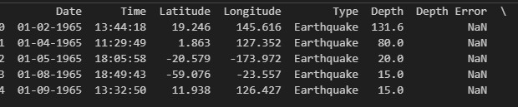

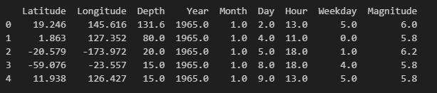

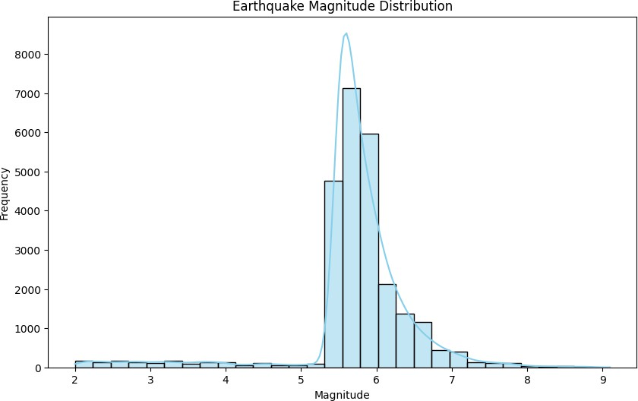

Fig:9.1.Earthquake Magnitude Distribution

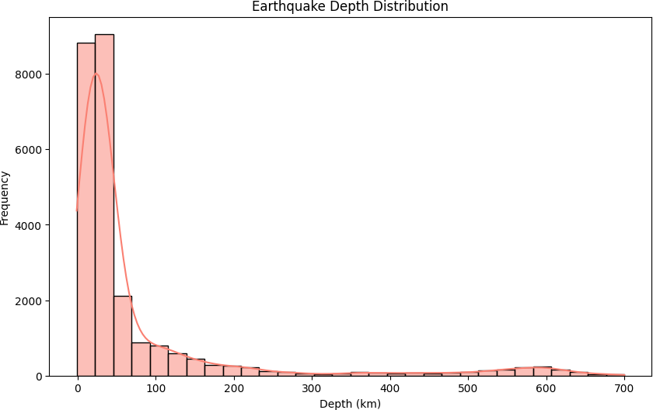

Fig.9.2.Earthquake Depth Distribution
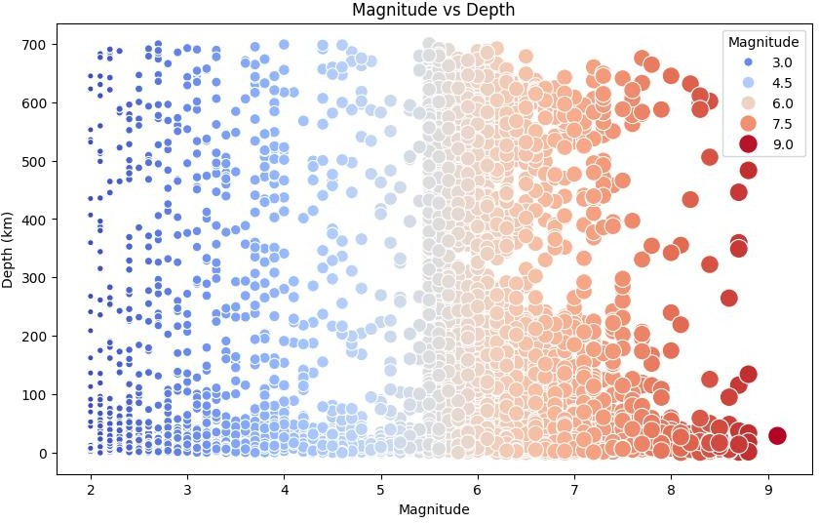

Fig.9.3.Magnitude vs Depth

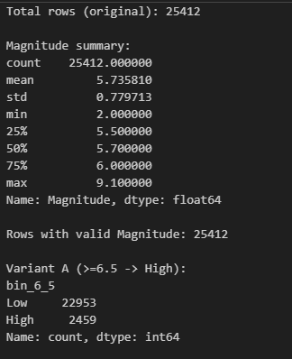

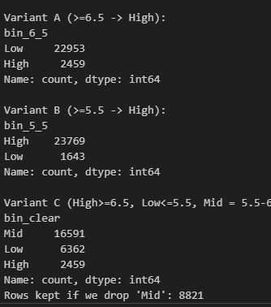

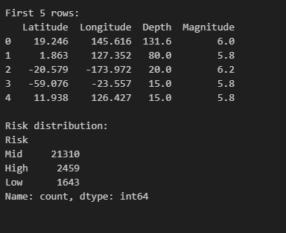

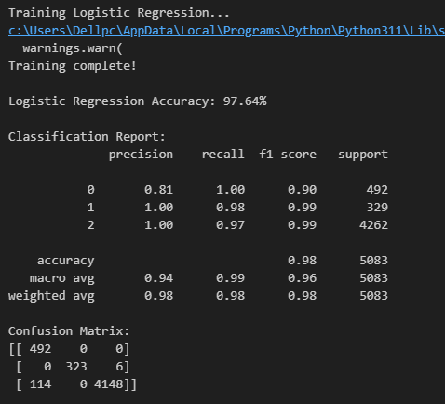

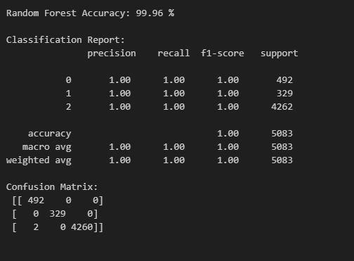

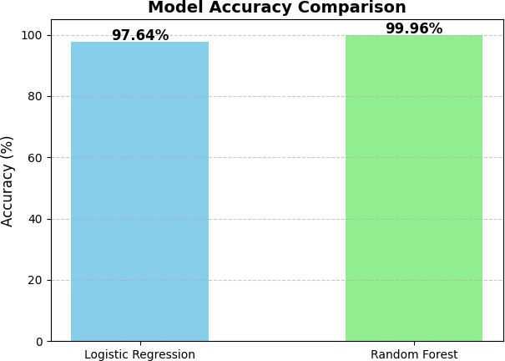
Fig.9.4.Model Accuracy Comparision

REFERENCES
- S. K. Abid, N. Sulaiman, S. W. Chan, U. Nazir, M. Abid, H. Han,A. Ariza-Montes, and A. Vega-Muñoz, ‗‗Toward an integrated disastermanagement approach: How artificial intelligence can boost disastermanagement,‘‘ Sustainability, vol. 13, no. 22, p. 12560, Nov. 2021.
- M. Breunig, P. E. Bradley, M. Jahn, P. Kuper, N. Mazroob, N. Rösch, M. Al-Doori, E. Stefanakis, and M. Jadidi, ‗‗Geospatial data managementresearch: Progress and future directions,‘‘ ISPRS Int. J. Geo-Inf., vol. 9,no. 2, p. 95, Feb. 2020.
- Darabi, H.; Rahmati, O.; Naghibi, S.A.; Mohammadi, F.; Ahmadisharaf, E.; Kalantari, Z.; TorabiHaghighi, A.; Soleimanpour, S.M.; Tiefenbacher, J.P.; Tien Bui, D. Development of a novel hybrid multi-boosting neural network model for spatial prediction of urban flood. Geocarto Int. 2021, 1–27. [CrossRef]
- A. Goel, A. K. Goel, and A. Kumar, ‗‗The role of artificial neural networkand machine learning in utilizing spatial information,‘‘ Spatial Inf. Res.,vol. 31, no. 3, pp. 275–285, Jun. 2023.
- D. Hong et al., —SpectralGPT: Spectral remote sensing foundation model,‖ IEEE Trans. Pattern Anal. Mach. Intell., vol. 46, no. 8, pp. 5227–5244, Aug. 2024.
- D. Hong, B. Zhang, X. Li, Y. Li, C. Li, J. Yao, N. Yokoya, H. Li, X. Jia, A. Plaza, P. Gamba, J. A. Benediktsson, and J. Chanussot, —SpectralGPT: The first remote sensing foundation model customized for spectral data,‖ Oct. 2023.
- P. Liu, Y. Zhang, and F. Biljecki, ‗‗Explainable spatially explicit geospatialartificial intelligence in urban analytics,‘‘ Environ. Planning B, UrbanAnalytics City Sci., vol. 51, no. 5, pp. 1104–1123, 2023.
- S. Lahiri, B. Snowden, J. Gu, N. Krishnan, H. Yellin, and K. Ndiaye,‗‗Multidisciplinary team processes parallel natural disaster preparednessand response: A qualitative case study,‘‘ Int. J. Disaster Risk Reduction,vol. 61, Jul. 2021, Art. no. 102369.
- V. Linardos, M. Drakaki, P. Tzionas, and Y. Karnavas, ‗‗Machinelearning in disaster management: Recent developments in methods andapplications,‘‘ Mach. Learn. Knowl. Extraction, vol. 4, no. 2, pp. 446–473, May 2022.

- Y. Yang, X. Sun, J. Dong, K.-M.Lam, and X. Xiang Zhu, ‗‗Attention-ConvNet network for ocean-front prediction via remote sensingSST images,‘‘ IEEE Trans. Geosci. Remote Sens., vol. 62, 2024,Art. no. 4212516.

